Excel to create a sales dashboard for an online store. It helps turn data into insights on delivery times, sales, profit, and regional performance, so management can make informed decisions.
Step 1 - Data Preparation Removed duplicate orders Checked and fixed missing values Made dates proper format Added new columns: Month, Year, Profit Margin, Aging Category Data is now clean and ready for analysis 😊
Step 2 - Action: Made a histogram of the “Aging” column with bins 0‑5 days, 6‑10 days, 11‑20 days, 20+ days.
Findings: Most orders are shipped in 5‑10 days, showing good fulfillment speed. No orders take over 20 days, pointing to possible delays.

Step 3: Made a PivotTable with months in rows and Sales & Profit as values.
Findings: Sales were highest in December, but profit margin was best in March, showing different seasonal trends for sales and profitability.

Step 4: Made a clustered column chart from the PivotTable. Added axis titles and formatted bars.
Findings: The chart shows monthly ups and downs clearly, making it easy to spot trends.

Step 5: Made a PivotTable with Region and Sales.
Findings: West region sells the most, South region needs a boost.
Step 6: Created a clustered column chart from the regional PivotTable. Sorted regions by descending sales.
Findings: The chart clearly shows regional differences, supporting location-based strategic planning.

Step 7: Combined all charts into a Dashboard sheet. Added slicers for Region, Category, Months.
Findings: The dashboard gives a clear, interactive view of sales performance.

Step 8 : Used Data Analysis ToolPak for stats and histograms.
Findings: Confirmed average sales and shipping efficiency patterns.
The dashboard shows order speed, monthly trends, and regional sales — helps management make quick, data-driven decisions.

Histogram Chart
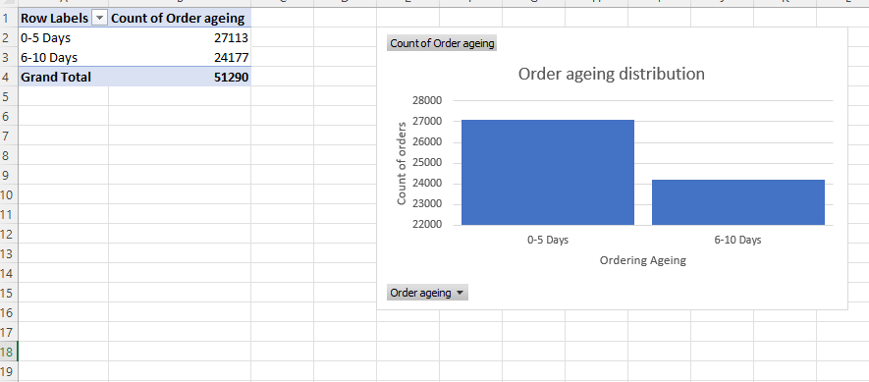

Pivot
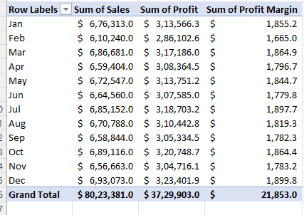

Pivot + Chart
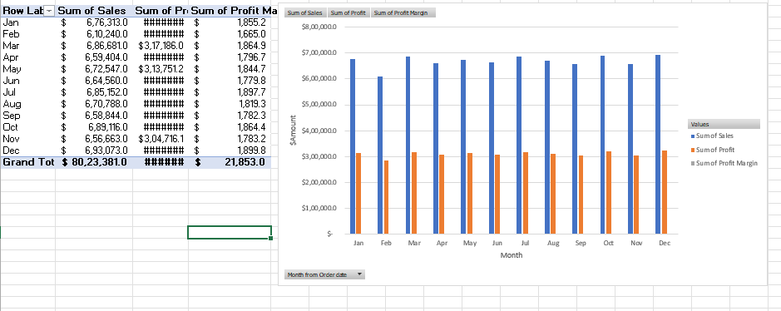

Region Pivot and chart
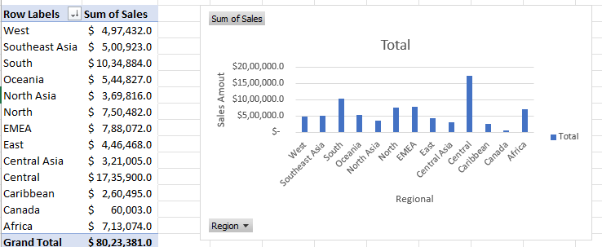

Dashboard
